📌 How does pip install boardfarm3 actually resolve?
✅ Behavior per pip documentation:
According to pip’s own documentation, when you run:
pip install boardfarm3
pip follows these resolution steps:
- Checks if it’s already installed (and meets version specifiers).
- If not:
  - Attempts to interpret boardfarm3 as a URL, then
  - As a local directory with pyproject.toml or setup.py, then
  - As a local archive, then
  - Finally as a package name (e.g. on PyPI or custom index)
- If you type:
pip install ./boardfarm3
pip bypasses all lookup logic and directly installs the directory in editable or regular mode.
🔍 Note: It does not randomly search the current directory—only if the argument exactly matches a directory path that pip can validate (with metadata), does pip treat it as a local install candidate.

🧪 Editable installs: pip install -e
✅ Documentation details:
When using -e (editable flag):
- For local directories, pip expects a valid setup.py or pyproject.toml. If found, pip installs the project in editable mode, creating .egg-info or .pth pointing to the source.
- The search precedence remains: URL → Directory → Archive → Package name. Pip installs local directory only if the path exactly matches one that pip can interpret. Otherwise, it treats it as a package name, failing if not found.

🧩 1. Does a dependencies = ["mypackage==1.2.*"] in pyproject.toml result in pip install mypackage==1.2.?
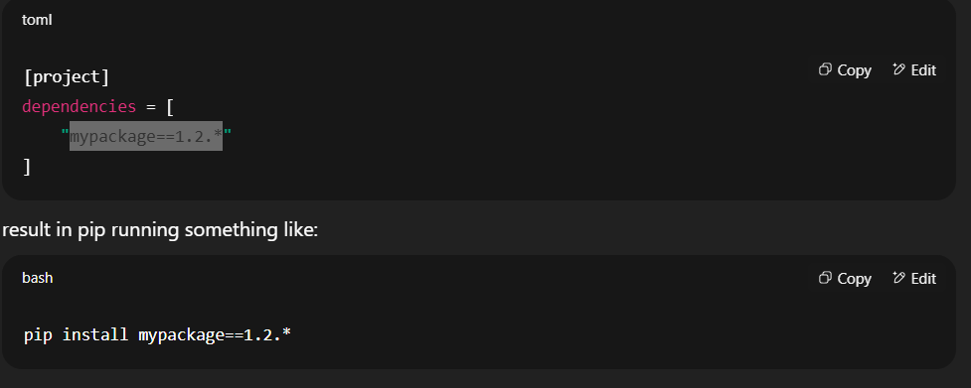
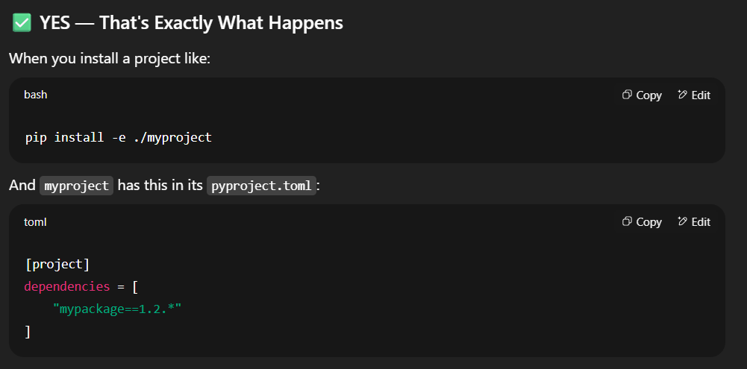
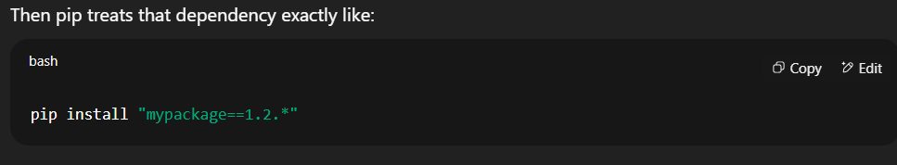 That means:
- It first checks if mypackage is already installed and satisfies the version.
- If not, pip:
  - Looks for mypackage on PyPI or your custom index URL
  - It does not automatically resolve to a local folder like ./mypackage unless you've already installed that locally (e.g., using pip install -e ./mypackage)
📌 Important: Just having a folder named mypackage in your current directory won’t matter. pip only treats it as a local install if you give it a path explicitly.

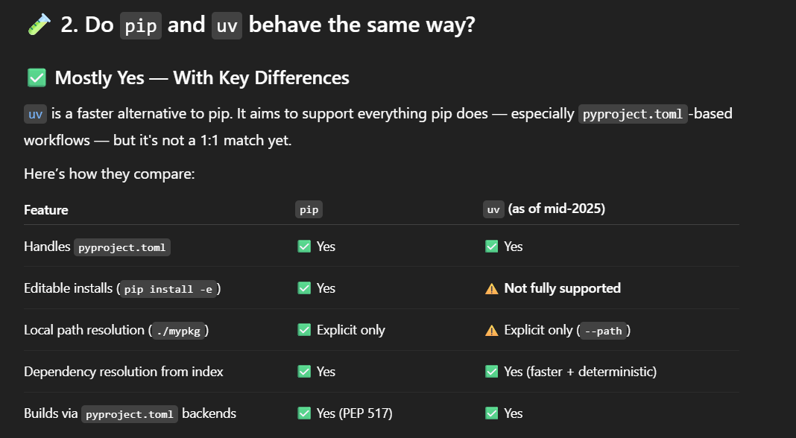

🚨 uv does not fully support pip install -e
As of July 2025:
- uv does not support pip install -e ./mypackage properly.
- If you try it, you’ll likely see an error or it will silently skip editable behavior.
- This is a known issue tracked in uv’s GitHub.

